SPRING MVC
Thursday, July 17, 2014
Introduction to MVC:-
- In the early days of java based web application development, we used a servlet, to define all the logic needed to handle a request and also the logic for generating the response to the client.
- A servlet itself contain business logic and presentation logic also.

Browser Servlet
Reads request parameter
Connects to database
Process the business
Applies presentation to the data

Database

request

response

- In the next days, the business logic of servlet is moved to java bean. It is a servlet to bean communication.
- In servlet to bean communication, a servlet will take care about presentation for the response data and bean takes care about processing the request by reading the data from database.
- In this servlet to bean communication, the business logic and the presentation logic are separate.

Browser Servlet JavaBean
Reads request parameter

Database
Connect to database
Processes the business

req set

res get

- The above two approaches of developing web applications is called model1.
- In order to clearly separate business logic and presentation logic i.e. to get the loose coupling between business logic and presentation logic, next we got MVC (Model View Controller) model.
- MVC model is called model2 in web application development.
- In MVC model apart from servlet and java bean jsp also introduced.
- In MVC model java bean takes care about business processing of request and jsp takes care about presentation and both are controlled by a servlet.
- According to MVC, a controller maintains control flow of the project, model contains business and a view contains presentation.

Browser Servlet
JavaBean
EJB
Spring
Database
JSP
1
2
3
4
5
6
7

request Model

View

response

Friday, July 18, 2014
Q. Why Servlet is a controller in MVC?
Ans.
- If a bean is taken as controller then a controller primary responsibilities is accepting http request, but a bean is unaware about http protocol. So a bean is not suitable to act as controller.
- If a jsp is taken as controller then it can accept http request, but for control flow management, huge java code needed in jsp. According to real-time applications development, we should not insert huge java code in a jsp is not suitable to act as a controller.
- Finally, we take a servlet component as a controller to do control flow management.
Q. Why bean is a model?
Ans.
- If we take servlet as a model then we should implement business logic in a servlet. The business implemented in servlet will not obtain more services from its web container. So servlet is not suitable to act as model.
- If jsp is taken as model then we should insert business logic in jsp. But inserting huge java code is against of industry standard.
- Finally a bean is suitable to implement business logic of MVC project.
Q. Why jsp is a view?
Ans.
- If we take bean as a view then a bean should write http response to a browser but a bean is unaware about http protocol. So a bean is not suitable to act as view.
- If a servlet is taken as a view then a servlet can write http response to the browser. But, presentation is not a fixed, so whenever presentation of servlet is modified then immediately we need to recompile the source code, reload the project sometimes restart the server. So servlet is not a suitable component.
- Finally a jsp is suitable for view, because a jsp can be modified at server by without re-compiling and re-loading.
Q. What is the difference between MVC and MVC2?
- In MVC controller calls model directly. But in MVC2, a controller calls model through helper class.
Important classes of spring MVC flow?
DispatcherServlet:-
- It is the front controller of a spring MVC project.
- This DispatcherServlet is only one servlet exists in the spring MVC project.
- This servlet class manages the flow of a request, by reading spring configuration file.
- Because it is a servlet, we need to configure this class in web.xml
HandlerMapping class:-
- It is the helper class of DispatcherServlet.
- This class identifies appropriate controller bean of a spring MVC project based upon the given request.
- Because of DispatcherServlet is using HandlerMapping class to identify a controller bean, we say that spring MVC follows MVC architecture.
Controller bean class:-
- In spring framework, controller servlet and controller beans are different.
- A controller bean class comes under model of MVC.
- In a controller bean class we define business logic needed to process a request.
ModelAndView class:-
- An object of this class returned from controller bean class to DispatcherServlet.
- An object of this class contains a logical name to identify an appropriate view and , model data to be displayed by a view.
ViewResolver class:-
- It is another helper class of DispatcherServlet.
- This class identifies appropriate view, based on model and view object.
- A DispatcherServlet will forward the request to the view and finally that view will send response to the browser.
Saturday, July 19, 2014
Diagram…………………….
- When a request comes from browser, then a first stop of the request is a DispathcerServlet.
- DispatcherServlet calls a HandlerMapping class configure in a spring configuration file.
- DispatcherServlet gets appropriate controller bean to handle the request, from HandlerMapping class and then calls that control bean class.
- A method in controller bean class applies processing the request and finally returns ModelAndView object.
- DispatcherServlet calls ViewResolver class and ViewResolver class identifies appropriate view based on model and view object.
- DispatcherServlet forwards the request to appropriate view and finally a view generates response to the browser.
Configuring web.xml
<web-app>
<servlet>
<servlet name>spring></servlet>
<servlet class>org,springframework.web.DispatcherServlet</servlet-class>
<load-on-startup>1</load-on-startup>
<init-param>
<param-name>contextConfigLocation</param-name>
<param-value>/WEB-INF/spring-servlet.xml</param-value>
</init-param>
</servlet>
<servlet-mapping>
<servlet-name>spring</servlet-name>
<url-pattern>/*</url-pattern>
</servlet-mapping>
</web-app>
- In the above web.xml configuring init parameter contextConfigLocation is optional. Because the spring configuration files following the naming <rule servletname>-servlet.xml and it is placed in WEB-INF folder.
- If a spring configuration file do not follow naming rule principle or if the config file is not placed in WEB-INF folder, in both cases we must configure init parameter in web.xml
- A web container reads web.xml and creates DispatcherServlet object. DispatcherServlet reads spring configuration file and creates ApplicationContext object of spring (spring container).
- There are three major implementation classes of ApplicationContext are,
- ClassPathXMLApplicationContext
- FileSystemApplicationContext
- XMLWebApplicationContext.
- aDispatcherServlet creates an object of XML web application context.

Container web.xml
DispatcherServlet

Spring-servlet.xml

- In spring MVC, the default extension added for url pattern for the request is .form. We can change it while developing the application.
- In above web.xml, we configure the url pattern as /*. This is universal url pattern, it matches for all the request.
BeanNameURLHandlerMapping:-
- This handler mapping class, checks url pattern of the request and a bean name, both are matched or not, to identify appropriate controller bean for the given request.
- This handler mapping class checks with bean name, but not bean id
- For example, if a request comes with url pattern /login.form then this handler mapping class checks a bean whose name is /login.form.
Monday, July 21, 2014
How to create the controller bean?
Ans.
- We have two ways of creating a controller bean.
- Implement Controller interface/ extend on of sub-classes of Controller interface.
- Annotations.
public classes MyController implements Controller
{
@Override
public ModelAndView handleRequest(req, res)
{
.................
}
}
//Annotation
@Controller
public class MyController
{
@RequestMapping("/login")
public ModelAndView loginCheck()
{
...................
}
}
About ModelAndView class:-
- A controller bean of spring mvc returns an object of ModelAndView class to DispatcherServlet, after processing a request.
- A ModelAndView class object contains logical name of the view and a model data to be displayed by a view.
- A ModelAndView class object can be created in 2 ways
- Model AndView mav = new ModelAndView(“logicalname”)
- ModelAndViw mava = new ModelAndView(“logicalname”, key,value);
Tuesday, July 22, 2014
package com.sathay.spring.controller;
import org.springframework.stereotype.Controller;
import org.springframework.web.bind.annotation.Request;
import org.springframework.web.servlet.ModelAndView;
@Controller
public class WelcomeController{
@RequestMapping("/welcome");
public ModelAndView welcome()
{
ModelAndView mav = new ModelAndView("sucess","message","Welcome to Spring MVC");
return mav;
}
}
<beans xmlns...>
<context:component-scan base-package="com.sathya.spring.controller">
<!-- View resolver bean-->
<bean id = "viewResolver" class="org.springframework.web.servlet.view.InternalResourceViewResolver">
<property name="prefix" value="/">
<property name="sufix" value=".jsp"/>
</bean>
</beans>
- To the lib folder add following 2 new jars apart from the previous example jars.
- Spring-aop.jar
- Aopalliance.jar
- In the above example, we have used two annotations in controller bean, @Controller and @RequestMapping.
- @Controller is a stereotype annotation and it is a sub annotation of @Component.
- If @Controller annotation is added on top of the class then that class becomes a controller bean and also it will be automatically configure by the container in component auto scanning.
- @RequestMapping annotation, maps a request with one url pattern to one method of controller bean.
- If annotations are used in controller bean then DispatcherServlet calls DefaultAnnotationHandlerMapping class, to find appropriate controller to handle the request.
- @RequestMapping annotation contains two attributes value and method.
- value attribute is to pass url pattern and pattern attribute is to pass a request method.
- The default value of method attribute is GET.
@RequestMapping(value=”/welcome”, method=”RequestMetho.POST”)
{
MAV welcome()
{
…………………..
}
}
- Welcome is executed for POST request, not for GET request.
- In the above example, we used java code under scriplet tag, for reading a request scope attribute in success.jsp. But we can reduce that code by adding EL (expression language) tag of jsp like the following.
<h1>${message}</h1>
- Above el tag will search for the key starting from page scope to the next levels. If it found in any scope then its value will be displayed and if not found then a white space will be displayed but not null.
- The following example is a login application, we will get the result as either success page or a login page again.
- If the given username and password are matches then we will get the response as success and if fail then we get login page back again.
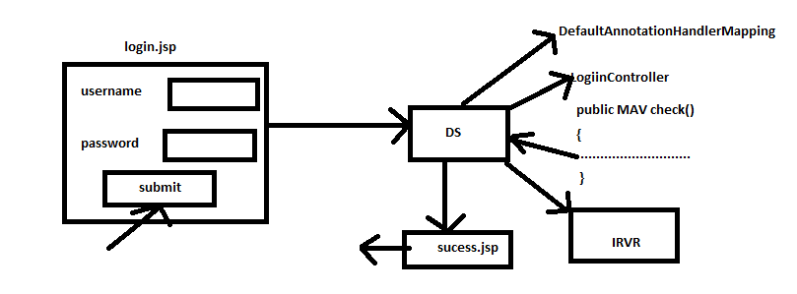
Project Structure:

<%@taglib uri="http://java.sun.com/jsp/jstl/core" prefix=c"%>
<html>
<body>
<c:if test="${message ne null}">
<c:out value="${message}"/>
</c:if>
<form action="check.html" method="psot">
Username<input type="text" name="uname"/><br>
Password<input type="password" name="pwd"><br>
<input type="submit" Value="SUBMIT">
</form>
</body>
</html>
@Controller
public class LoginController
@RequestMapping(value=”check”, method=”RequestMethod.POST”)
public ModelAndView check(@RequestParam("uname")String str1, @RequestParam("pwd")String str2)){
if(str1.equals("satya") && pwd.equals("password"))
{
return new ModelAndView("sucess", "message","Login Sucess");

}
else
{
return new ModelAndview("login", "message", "Username and Password is incorrect")
}
}
}

<beans xmlns...>
<context:component-scan base-package="com.sathya.spring.controller">
<!-- View resolver bean-->
<bean id = "viewResolver" class="org.springframework.web.servlet.view.InternalResourceViewResolver">
<property name="prefix" value="/">
<property name="sufix" value=".jsp"/>
</bean>
</beans>
Success.jsp
<h1>
${message}
</h1>
- Add following jars to build path
- Jstl
- Jstl-api
- Spring-context
- Spring-web
- Sprint-web-mvc
- Lib
- Jstl
- Jstl-api
- Spring-context
- Spring-web
- Sprint-web-mvc
- Aopalliance
- Commonslogging
- Etc………………

Wednesday, July 23, 201
Spring MVC Validation:-
- In a spring MVC project, the validations on input values at server side can be done in two ways.
- Programmatically
- Declaratively
- Programmatic validation means, we should manually define the input validations logic in a method of controller bean class.
- Declarative validation means, we use annotations of validation api of javaEE6 and annotations of hibernate validator api.
- For input validations, spring framework has not given any annotations. But spring allows to use the annotations of javaEE and hibernate validator.
- If you want to apply validation in a spring mvc project with annotations then we must store the input values of a request in a java bean object. We call that object as a command object and that class as a command class.
- When a request submitted, then to store the input values of request in a command object, the form of jsp page must be designed through spring framework tags.
- We should define a properties file (Resource Bundle) for defining error messages for validation errors.
- In order to configure the resource bundle name, we should configure a bean called ResourceBundleMessageSource class.
- In a declarative validations, to apply validation through annotations, the annotations are added to the fields of command class of application.
- If a jsp page contains spring framework given form tags then before form displayed on browser, the tags verifies the respective properties are present in command class or not.
- In order to verify, the framework class need command class object. They retrieve command class object from request attribute.
- In order to store a command class object in a request attribute, a method of controller bean executed.
- A method of controller bean is called by DispatcherServlet.
- A jsp page which consists framework tags will come to the browser with the help of the following flow.
- From browser a request will be send to DispatcherServlet.
- DispatcherServlet calls controller bean method.
- Controller bean method returns ModelAndView object, by setting command class object to the request attribute.
- DispatcherServlet calls view resolver
- The identified view checks the properties are present in command class or not.
- If yes then the view will be displayed on the browser and if no exceptions will be thrown.
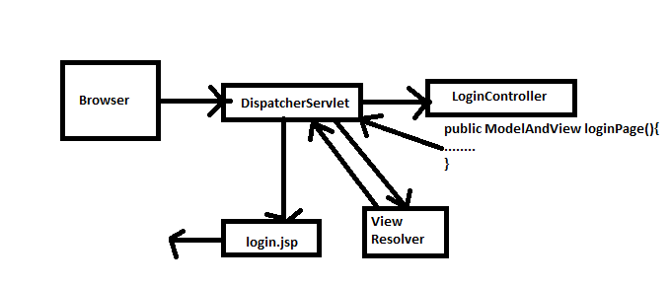

Thursday, July 24, 2014
- In the following login application, we are applying validations through annotation on username and password.
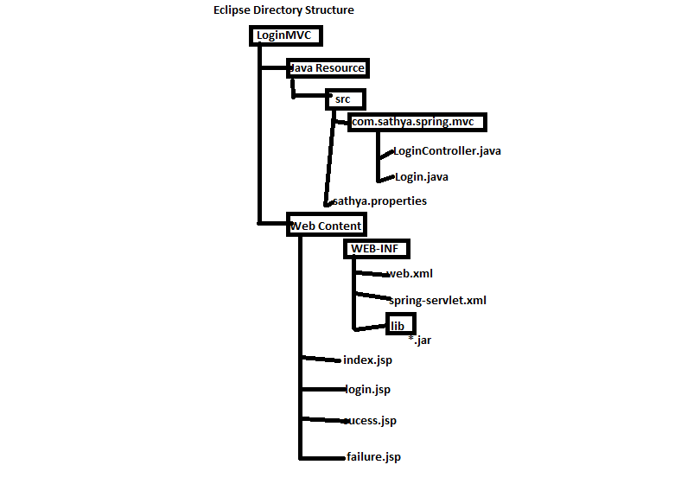

<!—index.jsp -->
<jsp:forward page = "login.form"></jsp:forward>
<!-- Login.jsp -->
<%t@taglib uri = "http://www,springrramework.org/tags/form" prefix = "form"%>
<center>
<br>
<form:form method="post" action = "check.form' commandName="login"> <!--login -- key of the command class object-->
<form:input path="uname"/><form:errors path="uname"/><br> <!-- To show the error messages -->
<form:password="pwd"/><form:errors path="pwd"/><br>
<inout type="submit" value ="click"/>
</form:form>
</center>
//Login.java
package com.sathya.spring.mvc;
import javax.validation.contraints.Size;
import org.hibernate.validatior.constraints.NotEmpty;
public class Login
{
@NotEmpty
private Stirng uname;
@NotEmpty
@Size(min4, maz=10)
private String pwd
//create setters and getters
}
//LoginController.java
package com.sathya.spring.mvc;
import javax.validation.Valid;
public class LoginController
{
@RequestMapping(value="loginpage", method=REquestMethod.GET)
public ModelAndView getLoginPage()
{
returnnew ModelAndView("login","login",new Login());
// logical name, key, Object
}
@RequestMapping("vlue="check", method =Request.POST);
public ModelAndView processRequest(@Valid Login login, BindingResult errors)
//Valid --- > This annotation executes validations added in command class
//BindingResult --- > This object stores the validation errors
{
if(errors.hasErrors())
{
return new ModelAndView("login");
}
else
{
String username=login.getUnane();
String password=login.getPwd();
if(username.equals("satya") && password.equals("satya"))
return new ModelAndView("sucess");
else
return new ModelAndView("failure");
}
}
}
<beans......><!-new namespace mvc will be add- -->
<context:component-scan base-package="com.sathya.spring.mvc">
<!-- View Resolver -->
<bean id="ViewResolver"spring.framework.web.servlet.InternalResourceViewResolver>
<property name="prefix" value="/"/>
<property name="sufix" value=".jsp"/>
</bean>
<bean id='messageSource' class ="org.springframework.context.support.ResourceBundleMessageSource">
<property name='basename' valur="sathya"/> ---sathya is the base name of resource bundle
<bean>
<mvc:annotation-driver> --- To enable annotations validations
<beans>
Resource bundle -------------
#This is a bundle with error messages
NotEmpty.login.unam=Username is Required
NotEmpty.login.pwd=Password is Required
Size.login.pwd=Password shoul contain {2} to {1} characters
# The syntax of writing errors message is
#Annotaiton.commandobject.field=error message
//success.jsp
<h1>
Login Success
</h1>
//failure.jsp
<h2>
Login Failure
</h2>
- Add following jars in buildpath:
hibernate-validtor, javax.validation, servlet-api, spring-beans, spring-context, spring-web, spring-webmvc
- Add following jars in lib folder
commons-logging, hibernate-validator, javax.validation, slf4j-api, spring-beans, spring-context, spring-context-support, spring-core, spring-expression, spring-web, spring-webmvc
Note:-While validating annotations, if we do not define error message for a validation then default error messages are going to be displayed.
We can type error message for a validation along with annotation only or we can get the error message from resource bundle.
@NotEmpty(message=”Username is mandatory”)
private String uname;
If error message defined with annotations and also in bundle then the priority goes to message of bundle
File uploading in Spring MVC :-
- File uploading is nothing but sending a copy of the file from client system to a server-side application.
- Once a file is uploaded to server-side application, then that application can store it in a server hard disk or it can store in a database.
- Spring framework has not given its own api for receiving an uploaded file. But it uses commons-fileupload api given by apache.
- In most of the real-time applications, the uploaded file is saves in hard disk and its path will be saved in database.
Friday, July 25, 2014
- To allow end-user for selecting a file, in order to upload in to the server, we need a file input text box.
- To get a file input text box on browser, we use <input type=”file”> tag.
- A file can be uploaded only through http POST method, so we need to change http method in to POST.
- To tell the browsers that don’t apply encryption on file data, we add enctype=”multipart/form-data” attribute to the <form> tag.
- When a request is received, DispatcherServlet calls a bean called CommonsMultiPartResolver for the request. This bean creates MultiPartFile object for the uploaded file and returns back to DispatcherServlet.
- CommonsMultiPartResolver internally uses commons-fileupload api of apache.
- While calling a controller bean method, DispatcherServlet will send MultipartFile object as a parameter to that method.
- In controller bean method, we define the logic either for storing the uploaded file in server system or in database.
Saturday, July 26, 2014
- We call following methods of MultiPart file interface of a controller bean to read file name, size, content type and data.
- getOriginalFileName()
- getSize()
- getContentType()
- getBytes()
- In the following application, we are allowing only xml file which is not empty to upload from client to server
- Diagram……………….
- Refer page1 of Handout
- In FileUploadController.java at line 34, we saved uploaded file in E:\ drive directory. But if doesn’t contain E:\ drive then application fails.
- In order to make application as independent to the system, we have to store the uploaded file in the root folder of an application.
- If we want to get path up to root folder of a system, we call getRealPath() method of ServletContext.
- In a controller bean, first we need to get session object through request object and then context object through session object.
- At line 34 of handout, we need to include the below statements
HttpSession session = request.getSession();
ServletContext ctx = session.getServletContext()
String path = ctx.getRealPath(“/”)
FileOutputStream fos = new FOS(path+“/”+file.getOriginalName());
I18N in Spring:- (InternationalizatioN in Spring with MVC)
- I18N is a mechanism of changing the content of a web page on a browser according to the selected language or country, by without making any technical changes to the project.
- In java, if we want to develop I18N based application then we need to prepare resource bundles with messages of particular languages.
- If suppose, we want to support three languages in the project, then we need to create three resource bundles, one for each language.
- The resource bundles names should follow a naming principle, “basename_languagecode_countrycode.properties”.
- Language code and country code are given by ISO and country code is optional.
- Base name for all bundles must be same.
messages_hi_IN.properties
messages_or_IN.properties
messages_en_IN.properties
- While defining resource bundles, keys in all bundles should be same, but their values are different from one bundle to another bundle.
Wednesday, July 30, 2014
- The tiles programming is used for creating for composite view pages in a MVC project.
- Using tiles programming we can separate the layout of the composite view and content of the composite view.
- In the layout page the structure of the composite view page is designed and i.e. inserted in the composite view page.
- The advantage of separating composite layout from content is, if any composite view pages designed is need to be modified then it can be modified easily just by changing the layout page.
- If once a layout page modified then all the composite view pages structure will be modified. So there is no need to modify the each composite view page separately.
- The spring mvc, we need to do the following changes in the project, to develop a tiles application.
- Create a layout page with Tiles tag of apache.
- Define a tiles definition xml file for defining the composite views.
- Configure a pre-defined spring framework class TilesConfigurer, to read the definition of tiles xml file.
- Configure a view class called tiles view of spring framework, to select appropriate composite view page from the tiles definitions.
- Add tiles related jars to the lib folder.
Thursday, July 31, 2014
- While defining a layout page, we use tiles tag of apache for assigning a name for each region.
- To use tiles tags of apache in a jsp page, we import its tag library like the following.
<%@taglib uri=”http://tiles.apache.org/tags-tiles” prefix=”tiles”%>
- In a tiles application, we define a tiles api for the definition of composite views. While defining the definition in xml, we can inherit one definition from another.
- TilesConfigurer is a class which reads tiles xml file, prepares a tiles container object and then stores it in ServletContext object.
- TilesView is a class, used by UrlBasedViewResolver class to find appropriate composite view from tiles container, based on logical name returned by ModelAndView object.
- Spring framework uses tiles api of apache internally. So we need to add the tiles api related jars to the lib folder of the project.
Example,
In the following example, we are creating three composite view pages with a header, menu, body and footer region.
Diagram……………………………………………………………………………
- Refer Page no. 6 of Handout-II
- Add the following jars to the build path
- servlet-api.jar 2. spring-beans 3. spring-context 4. spring-web 5. spring-webmvc
- Add following jars to the lib folder of the project.
- aopalliance
- commons-beanutils
- commons-digestor
- commons-logging
- javax.servlet.jsp.jstl-api
- slf4j-api
- spring-aop
- spring-beans
- spring-contex
- spring-context-support
- spring-core
- spring-expression
- spring-web
- spring-webmvc
- tiles-api
- tiles-core
- tiles-jsp
- tiles-servlet
- tiles-template
Pdf and Excel Response:-
- Spring framework has provided built-in support for generating response in a pdf and excel format for generating response.
- To generate the response in a pdf and excel format, the view should be a bean, but not a jsp.
- To construct pdf response, we extend our class from an abstract class called AbstractPdfView.
- AbstractPdfView class contain one abstract method buildPdfDocument. So we should override this abstract method.
public class MyPdfView extends AbstractPdfVies
{
@OVerride
public void buildPdfDocument()
{
.........
}
}
- AbstractPdfView class of spring framework internally uses iText api given by Bruno Lowagie, to generate pdf response. So we need to add iText.jar to the project.
- To generate response in excel format, we should extend an abstract class called AbstractExcelView.
- AbstractExcelView class contain one abstract method called buildExcelDocument. So we should override this method.
- AbstractExcelView class spring framework uses apache poi api for generating excel response. So we need to add poi.jar to the project.
Example,
Flow Diagrammmmmmmmmmmmmmmmmmmmmmmmmmmm
- When a bean as a view in a project, to identifies the appropriate view BeanNameViewResolver is used.
- BeanNameViewResolver identifies appropriate view bean, by matching logical name of the view and bean id.
Diagram…………………………………………
- Refer Page No 9 of Handout-II
- Add the following jars to the build path.
- iText.jar
- poi-final
- servlet-api.jar
- spring-beans
- spring-context
- spring-web
- spring-webmvc
- Add the foowing jars in lib folder
- Spring related jars+ iText.jar+poi-final.jar
Friday, August 01, 2014
ResourceBundleViewResolver:-
- This view resolver is used in a mvc project, if the location of views for the logical names are defined in a resource bundle (properties file).
- In the resource bundle, to define the location of a view, we need to append.url for a key.
- In the spring configuration file, the base name of the bundle should be configure along with ResourceBundleViewResolver class.
- The advantages of ResourceBundleViewResolver over InternalResourceViewResolver is, in IRVR the prefix and suffix of the views are fixed. But in RBVR, prefix and suffix of views can be any.
@Controller
public class MyController
{
@RequestMApping("login");
public ModelAndView check (......)
{
if(......)
return ModelAndView("sucess")
else
return ModelAndView("failure")
}
}

<bean id="id" class="o.springframework.web.servlet.view.ResourceBundleViewResolver">
<property name="basename" value="views"/>
</bean>

views.properties
sucess.url=/sucess.jsp
failure.url=/failure.html
- In the above sample code, one view is a jsp and other view is a html and their prefix is not same.
- If ModleAndView contain a logical name as success then this view resolver selects success.jsp as views. If the logical name is failure then view selected as failure.html
- If views in an application are defined in an xml file then this XmlViewResolver is used.
- XmlViewResolver verifies whether a logical name and bean id are matched or not. If matched then the page configure with url property will be send to DispatcherServlet.
@Controller
public class MyController
{
@RequestMApping("login");
public ModelAndView check (......)
{
if(......)
return ModelAndView("sucess")
else
return ModelAndView("failure")
}
}
<!-- views.xml -->>
<bean id="sucess" class="org.springframeworl.web.servlet.view.JstlView">
<property name="url" value="/sucess.jsp"/>
</bean>
<bean id="failure" class="org.springframework.web.servlet.view.JstlView">
<property name="url" value="/pages/failure.html"/>
</bean>

<!-- spring-servlet.xml -->
<bean id="vr" class=" org.springframework.web.servlet.view.XmlViewResolver">
<property name="location" value="/WEB-INF/views.xml"/>
</bean>
SimpleUrlHandlerMapping:-
- This handler mapping class is used, when a controller is defined without annotation.
- This handler mapping class identifies appropriate controller bean, by mapping url pattern of the request with bean id.

<!-- spring-servlet.xml -->
<bean id="hm" class="o.springframeworl.wwb.servlet.handler.SimpleUrlHandlerMapping">
<property name="amppings">
<props>
<prop key="/login.form">lc</prop>
<prop key="/welcome.form">wc</prop>
</props>
</property>
</bean>
<bean id="lc" class="LoginController"/>
<bean id ="wc" class="WelcomeController">
- If a request comes with url pattern as login.form then this handler mapping class selects LoginController as a suitable name and for welcome.form url pattern, WelcomeController as a suitable name.
……………………………………………………………….Missssssssssed 2 classessssssssss
Monday, August 04, 2014
Integrate Struts2 with Spring:-
- In Struts2 an Action class is a pojo class and if you want to integrate with spring then we need to call the business method of spring bean from Action class of Struts2.
- From the integration we need to configure a Listener class called org.springframework.web.context.ContextLoaderListener in web.xml of Struts2 along with the front controller filter of Struts2.
- We configure the Struts2 action class in spring configuration file and its id will be configured in Struts configuration file.
- In Struts2.x, struts configuration file should be struts.xml and it must be placed under classes folder.
